Lesson 8: Answer Key

Key for modeling force interactions in the launcher, cart, box, and track system

Treat this as an informal assessment of prior knowledge related to how forces from friction and air resistance act on moving objects. Do not correct preconceptions at this point. Make a copy of student responses on Modeling other force interactions in the launcher, cart, box, and track system so you can return the original to students to use when they revise their models for home learning in the next lesson. This will also provide you a reference to compare student thinking now (before Lesson 9) to what they are thinking later by the end of Lesson 9. Purple responses below show the target ideas you are looking for students to be using by the end of Lesson 8.

Q1) Draw and label two free body diagrams showing the contact forces between the box and the cart as they are moving together at time 4.

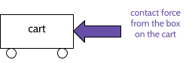 |  | 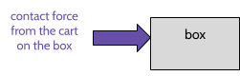

Q2) Besides the cart, what other objects or subsystems is the box either making contact with or colliding with at time 4?
The track and the air

Q3) Redraw your freebody diagram for the box to the right. Show all of these additional forces on it as well as the contact force from the cart at time 4. Don’t worry about representing the relative strength of these forces. Focus on showing which direction the forces would be pushing on the box and which surface they would be pushing on it. |  | 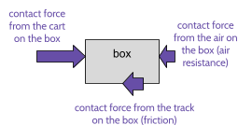

Q4) Do you think these kinds of forces are also acting on the cart as it coasts down the track at time 2? Why?

+ Air resistance would also be acting on the cart as it coasts down the track because it is an object moving through the air, hitting air particles as it goes. The cart is kind of box shaped, so the front face of it would have similar forces from air resistance on it in the same direction as those shown for the box.
+ Friction would be acting on the cart wheels, but they aren’t sliding over the track like the box and there is less surface area in contact with the track, so there would be less friction on the cart from contact with the track than on the box from contact with the track.

Q5) Where does this tell you some of the energy in the system might be going as the box and cart move down the track??

+ Some of the energy might be transferred to the air.
+ Some of the energy might be transferred to the track.

